Cloud Computing Systems Analysis: Christian Volunteer Service (CVS) Case Study
Name: Iyenoma Goodnews Osabuohien
Student ID: 26001003
Module: Cloud Computing | Code: UFCFKJ-15-M
Institution: University of the West of England, Bristol
Submission date: 30 July 2026
Word count: 2,020

Introduction
Christian Volunteer Service (CVS) is a national UK charity supporting vulnerable people across the country, employing 4,000 staff and operating 260 shops. Its current IT infrastructure costs £25.7 million annually, with £7 million spent on legacy systems that generated 15 days of operational downtime in 2016/17 alone. The Board has approved a £10 million budget to modernize these systems over three years. This report presents a systems analysis of the proposed changes, covering a SWOT analysis of current and future IT infrastructure, cloud service model recommendations, commercial provider and cost analysis, INaaS and BPaaS development proposals, and a sustainability evaluation of the selected provider.
Section 1: SWOT Analysis
- SWOT Analysis of CVS Current IT Infrastructure
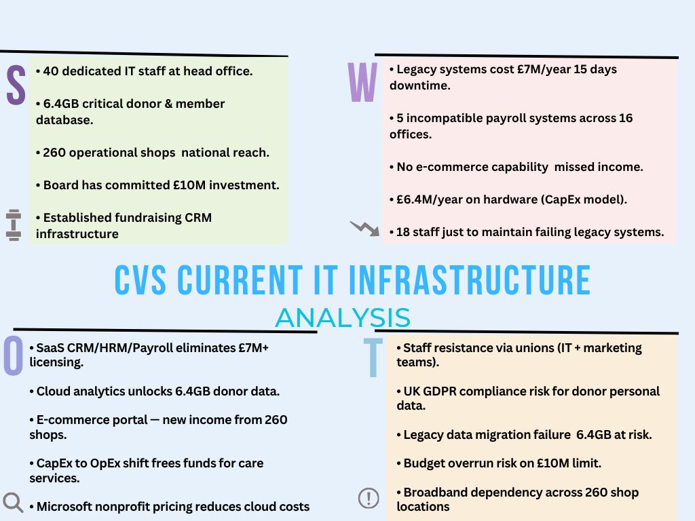
CVS's current IT infrastructure is critically weakened by legacy system dependency, spending £7 million annually on systems that generated 15 days of operational downtime in 2016/17 (CVS Case Brief, 2026). Despite possessing a skilled IT team and a 6.4GB donor database, the absence of e-commerce capability and incompatible regional payroll systems represent missed income and operational inefficiency that cloud migration can directly address (Khajeh-Hosseini et al., 2010).
- SWOT Analysis of CVS Proposed Cloud IT Infrastructure
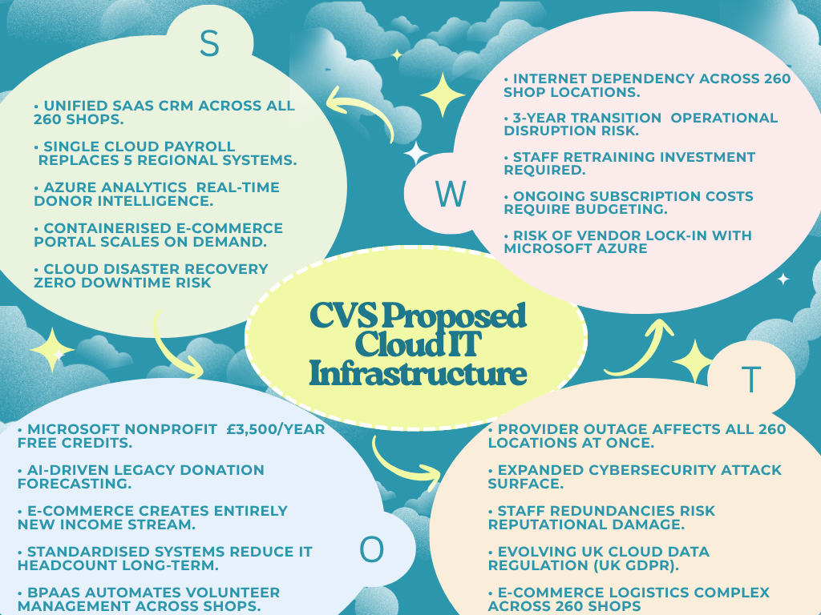
The proposed cloud infrastructure converts CVS's most critical weakness of £7 million in failing legacy systems into a strategic strength through SaaS consolidation and PaaS-enabled e-commerce. Microsoft Azure is recommended as the primary provider due to its nonprofit pricing program, UK data residency in the London region, and native integration with Microsoft tools already familiar to CVS staff (Microsoft, 2024). Migration risks, including staff resistance and data transition complexity, are manageable within the 3-year, £10M budget framework approved by the CVS Board.
Section 2: SaaS, PaaS and IaaS Service Provision Analysis
CVS does not need to keep pouring money into physical servers and on-site infrastructure. A layered cloud strategy fits the organization's needs far better: routine business functions move to software as a service, the new e-commerce platform is built on platform as a service using containers, and the legacy systems are migrated through infrastructure as a service, underpinned by virtualization. Together these address CVS's £6.4 million annual hardware spend directly.
IaaS and Virtualization
IaaS depends on virtualization, which allows several virtual machines to run independently on one physical server (Erl, Puttini, and Mahmood, 2013). For CVS, this means the cost of buying and maintaining physical servers is replaced by virtual machines billed only for what is used. Microsoft Azure Virtual Machines, hosted in the Azure UK South (London) region, are recommended for migrating CVS's legacy databases. Compared with AWS, Azure offers an extra financial advantage through its Microsoft for Nonprofits programmed, which provides eligible charities with around £3,500 in annual credit (Microsoft, 2024); support AWS does not offer in the same way. CVS's 6.4GB of legacy donor data can be moved to Azure Virtual Machines using a lift-and-shift approach as the first step in the migration. This keeps disruption low while protecting data integrity, and the 18 IT staff currently tied up maintaining failing legacy systems can be redirected to cloud management work, helping reduce the kind of downtime that cost CVS 15 working days in 2016/17 (CVS Case Brief, 2026).
PaaS and Containers
PaaS gives CVS a ready-made environment for building custom applications without having to manage servers or operating systems directly. The clearest use case is the national e-commerce platform, where all 260 shops upload photos of donated items for central pricing and online sale. Containers are a better fit here than virtual machines. A container bundles an application with everything it needs into one lightweight unit, sharing the host operating system rather than requiring its own, which makes containers faster to deploy and lighter on resources (Turnbull, 2014). This matters for CVS because item uploads will spike after weekend donation collections across all 260 shops, and containers can scale up quickly to absorb that kind of surge. Azure App Service is recommended as the PaaS platform, with the application containerized using Docker and managed through Azure Kubernetes Service, which automatically scales the number of running containers based on demand (Microsoft, 2024). AWS Elastic Beanstalk and Google App Engine offer similar capabilities, but Azure suits CVS better given its closer integration with existing Microsoft tools and lower in-house development skill requirement.
SaaS
SaaS lets CVS run on cloud-based applications instead of building and maintaining its own software. The Salesforce Nonprofit Success Pack is the recommended replacement for the current CRM. Its Power of Us program gives registered charities ten free user licenses (Salesforce, 2024), cutting costs while improving donor and volunteer management. For payroll, Sage Business Cloud Payroll consolidates CVS's five separate regional systems into one UK-compliant platform; ADP Workforce Now offers similar functionality, but Sage's UK-specific compliance makes it the more practical fit. Microsoft 365, paired with Dynamics 365 for HR, covers communication, document management, and staff administration. Since most CVS staff already use Microsoft products daily, training needs are lower, which matters when over 4,000 people need to adapt with minimal disruption.
Section 3: Commercial Service Provider and Cost Analysis
Microsoft Azure is the recommended cloud provider for CVS for three specific reasons. First, most CVS staff already use Microsoft products daily (Windows, Office, and Outlook), which means moving to Azure, Microsoft 365, and Dynamics 365 requires minimal retraining. The integration between these tools is built in, reducing implementation time and the risk of staff resistance (Gartner, 2023). Second, as a registered UK charity, CVS qualifies for Microsoft's Nonprofit Program, providing an annual credit of £2,660 (equivalent to $3,500 USD) towards Azure services alongside discounts of up to 75% on Microsoft 365 licenses (Microsoft Nonprofits, 2024; Compare the Networks, 2026). Third, Azure UK South stores all data within UK borders, satisfying UK GDPR obligations for CVS's 6.4GB of donor records without additional configuration (ICO, 2021). AWS was reviewed but set aside, as it offers no equivalent UK charity program and lacks the same Microsoft 365 integration depth.
The pricing structure maps three models from the module (Mazrekaj, Shabani, and Sejdiu, 2016). Azure Virtual Machines and App Service use a consumption-based model; CVS pays per CPU hour and per gigabyte used, eliminating idle server costs. Microsoft 365, Salesforce NPSP, and Sage Payroll use a subscription model, a fixed monthly fee per user, giving finance a predictable budget line. One-off migration and training costs in Year 1 follow fixed pricing, covering a nonrecurring outlay that does not repeat once the transition is complete.
CVS currently spends £8.5 million on software licensing and £6.4 million on hardware, £14.9 million annually in costs that generate diminishing returns. Research by Khajeh-Hosseini et al. (2010) found IaaS migration reduced infrastructure costs by 37% over five years, while McKinsey (2025) reports cloud migration reduces infrastructure costs by 20–40%. A conservative 30% saving on CVS's current spend would be over £4 million annually, money that can go directly to care services for vulnerable people.
Service | Provider | Pricing model | Est. annual cost
Azure Virtual Machines + Blob Storage | Microsoft Azure | Consumption | £400,000
Microsoft 365 Business Premium 4,000 staff (charity pricing) | Microsoft | Subscription | £211,200
Salesforce NPSP 120 fundraising staff | Salesforce | Subscription | £86,400
Sage Business Cloud Payroll | Sage | Subscription | £48,000
Azure App Service + Kubernetes Service | Microsoft Azure | Consumption | £220,000
Azure Synapse Analytics | Microsoft Azure | Consumption | £90,000
Azure Integration Services | Microsoft Azure | Consumption | £120,000
Year 1 migration, data transfer, training | Third party | Fixed (one-off) | £1,500,000
Post-migration annual running cost |  |  | £1.2M/year
(Microsoft 365 charity pricing at £4.40 per user per month Compare the Networks, 2026)
Section 4: INaaS and BPaaS Services and Development Analysis
Moving CVS's operations to the cloud creates an immediate integration challenge. Salesforce NPSP, Sage Payroll, Microsoft 365, Azure App Service, and the systems across 260 shops all generate data that needs to flow to one central place. Without this, each system becomes an isolated silo, and the board's ambition for strategic analytics cannot be realized. Integration as a Service (INaaS) provides cloud-based middleware connecting different systems through standardized APIs, removing custom point-to-point coding between every application (Rimal, Choi and Lumb, 2009). Microsoft Azure Integration Services Logic Apps, API Management, and Service Bus are recommended as CVS's INaaS layer. In practice, when a shop volunteer logs a donated item, the integration layer automatically triggers the central pricing workflow, records the donation in Salesforce, and notifies the regional manager, all without anyone entering the same information twice.
Business Process as a Service (BPaaS) delivers complete end-to-end business processes over the cloud, combining IaaS, PaaS, and SaaS layers to automate entire workflows (Duan et al., 2015). The BPaaS market reached $63.3 billion in 2023 and is forecast to reach $92.9 billion by 2028 (MarketsandMarkets, 2024). For CVS, three processes are proposed across the three-year project. In Year 1, the legacy donation workflow is automated: notification of a bequest, legal verification, fund allocation, and acknowledgement all run as a single cloud process, reducing dependence on the 12 IT support staff currently keeping these systems alive. In Year 2, the national e-commerce fulfillment process is introduced through a BPaaS workflow built on Shopify Plus connected to Azure Logic Apps. In Year 3, volunteer management across 260 shops moves to an automated onboarding and rota workflow, freeing shop managers to focus on customers and donations rather than spreadsheets.
Section 5: Sustainability Discussion
CVS's current on-premises server rooms are among the least energy-efficient ways to run IT. Traditional data centers typically operate at a Power Usage Effectiveness (PUE) of between 1.8 and 2.0, meaning almost an equal amount of energy goes to cooling as to computing (Uptime Institute, 2023). Microsoft Azure data centers average a PUE of 1.12 (Microsoft, 2024), roughly 40% more efficient per unit of computation, so migrating CVS's workloads to Azure delivers an immediate environmental improvement without CVS changing how it operates.
Microsoft has committed to becoming carbon negative by 2030 and removing all historical emissions by 2050 (Microsoft, 2024). Azure UK South runs under Microsoft's 100% renewable energy matching program, supported by power purchase agreements. The Microsoft Emissions Impact Dashboard, provided free to all Azure customers, reports Scope 1, 2, and 3 emissions, giving CVS a clear way to measure and report its cloud carbon footprint to its board and donors, both of whom expect a charity to demonstrate ethical practice.
That said, Microsoft's renewable claims rely on market-based renewable energy certificates rather than direct physical supply of green electricity. A distinction-independent analyst argues it overstates real-world impact (Carbone4, 2023). Even so, moving from CVS's poorly utilized on-premises servers to a hyperscale Azure facility is a genuine net environmental improvement. Cloud data centers achieve server utilization rates of 60–80% compared to roughly 15–20% in typical on-premises environments (Lawrence Berkeley National Laboratory, 2016), meaning fewer servers are needed to do the same work.
Conclusion
CVS's migration to Microsoft Azure is financially sound, operationally necessary, and environmentally responsible. Replacing failing legacy systems with SaaS applications for CRM, payroll, and HR; building a containerized e-commerce portal on PaaS; and migrating legacy data through IaaS removes over £14.9 million in annual IT costs and replaces them with an estimated £1.2 million recurring cloud spend. The savings generated over the three-year program can be redirected toward CVS's core mission of supporting the poor and vulnerable people it has served since the 1860s. Cloud migration is not simply a technology upgrade for CVS. It is the mechanism through which the organization funds the next chapter of its charitable work.

References
- Carbone4 (2023) The limits of renewable energy certificates in corporate carbon accounting. Paris: Carbone4. Available at: https://www.carbone4.com (Accessed: July 2026).
- Compare the Networks (2026): Microsoft 365 for charities in the UK: nonprofit pricing explained. Available at: https://comparethenetworks.com/blog/microsoft-365-for-charities-uk (Accessed: July 2026).
- Duan, Y., Fu, G., Zhou, N., Sun, X., Narendra, N.C., and Hu, B. (2015) 'Everything as a service (XaaS) on the cloud: origins, current, and future trends,' Proceedings of the 2015 IEEE 8th International Conference on Cloud Computing, New York: IEEE, pp. 621–628.
- Erl, T., Puttini, R., and Mahmood, Z. (2013). Cloud Computing: Concepts, Technology, and Architecture. Upper Saddle River: Prentice Hall.
- Gartner (2023) Magic Quadrant for Cloud Infrastructure and Platform Services. Stamford: Gartner Inc.
- ICO (2021) Guide to the UK General Data Protection Regulation (UK GDPR). Wilmslow: Information Commissioner's Office. Available at https://ico.org.uk/for-organisations/guide-to-data-protection (Accessed: July 2026).
- Khajeh-Hosseini, A., Greenwood, D., and Sommerville, I. (2010). Cloud migration: a case study of migrating an enterprise IT system to IaaS. arXiv [online]. Available at: https://arxiv.org/pdf/1002.3492 (Accessed: July 2026).
- Lawrence Berkeley National Laboratory (2016) United States Data Center Energy Usage Report. Berkeley: LBNL. Available at: https://eta.lbl.gov/publications/united-states-data-center-energy (Accessed: July 2026).
- MarketsandMarkets (2024) Business Process as a Service (BPaaS) market global forecast to 2028. Available at: https://www.marketsandmarkets.com (Accessed: July 2026).
- Mazrekaj, A., Shabani, I., and Sejdiu, B. (2016) 'Pricing schemes in cloud computing: an overview,' International Journal of Advanced Computer Science and Applications, 7(2), pp. 80–86.
- McKinsey and Company (2025) Cloud migration and infrastructure cost reduction: enterprise benchmarks. Available at: https://www.mckinsey.com (Accessed: July 2026).
- Microsoft (2024) Microsoft Sustainability Report 2024. Redmond: Microsoft Corporation. Available at: https://www.microsoft.com/sustainability (Accessed: July 2026).
- Microsoft Azure (2026) Azure Pricing Calculator. Available at: https://azure.microsoft.com/en-gb/pricing/calculator/ (Accessed: July 2026).
- Microsoft Nonprofits (2024): Nonprofit grants and discounts from Microsoft for Nonprofits. Available at: https://nonprofit.microsoft.com (Accessed: July 2026).
- Rimal, B.P., Choi, E., and Lumb, I. (2009) 'A Taxonomy and Survey of Cloud Computing Systems,' Proceedings of the 2009 International Joint Conference on INC, IMS, and IDC, Seoul: IEEE, pp. 44–51.
- Salesforce (2024) Power of Us program: nonprofit technology. Available at: https://www.salesforce.org/power-of-us (Accessed: July 2026).
- Turnbull, J. (2014). The Docker Book: Containerization is the new virtualization. Self-published.
- Uptime Institute (2023) Global data center survey 2023. Available at: https://uptimeinstitute.com (Accessed: July 2026).

Appendix A: Azure Pricing Calculator Estimate
Figure: Indicative Microsoft Azure infrastructure cost estimate for CVS's proposed cloud environment, configured for the UK South region using pay-as-you-go pricing. The estimate covers virtual machine, App Service, Kubernetes, Synapse Analytics, and Integration Services components only and excludes SaaS licensing costs (Salesforce, Sage, and Microsoft 365), which are billed separately by their respective providers. Generated using the Microsoft Azure Pricing Calculator (Microsoft Azure, 2026).
